**Lesson Notes**

1. What is the main purpose of an Operating System?

More efficient application programs, consistent user experience, and allow multiple applications running at the same time.

1. What is the difference between Operating System Software and Use Application Software?
2. What is the difference between Operating System Software and Computer Hardware?
3. What are the main parts of an Operating System?
4. What are some popular operating systems?

**Reference Diagram**

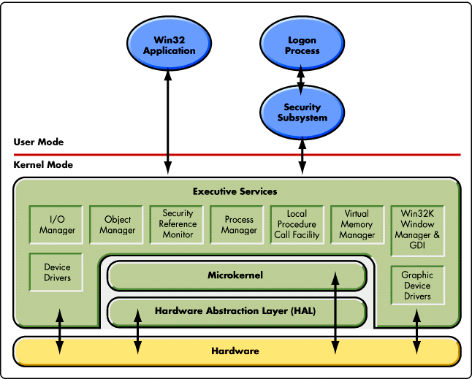

Locally attached printer

DDL

**Student Questions**

1. What is a device driver?
   1. Provide a brief summary

Software program that controls a type of hardware device that is attached to a computer.

* 1. List some devices that require a device driver.

Some devices that require a device driver are printers, displays, CD readers, network, mice, etc.

* 1. Provide a label on the reference diagram for the location of a device driver for your graphics card.
  2. Provide a label on the reference diagram for the location of a device driver for a locally attached printer.

1. What is a DLL?
   1. Provide a brief summary

Syntax for data structures, DDL creates, modifies, and remove database objects.

* 1. Explain how DLLs are relating to user application programs

It’s used for holding multiple codes and procedures for windows programs.

* 1. Provide a label on the reference diagram for the location of a DLL

1. What is a windows manager?
   1. Provide a brief summary

Windows manager is a software that controls the placement and appearance of windows.

* 1. Explain how a windows manager is related to user application programs

Provides a user experience which is organized and easy to approach/use.

* 1. Provide a label on the reference diagram for the location of a DLL

1. What is the windows task manager?
   1. Provide a brief summary

Windows task manager is a task manager, system monitor, and startup manager included with Microsoft Windows systems.

* 1. List and explain four (4) types of system information provided by the task manager

The four systems include management information systems, decision support systems, executive information systems, and expert systems. These are all meant to assist decision making in the system.

* 1. Provide a label on the reference diagram for the operating system components related to each type of information.